Open a Chrome Browser Session (preferably Chrome – Microsoft Edge appears to work, but Internet Explorer is currently supported – I have not tested Firefox)

Enter the address:
https://axios.integration.accountsiq.com:3000/

You should get login screen as illustrated below:

Click “Login”. You will need to provide a valid email address and password for the accountsiq.com domain (such as pmckeown@accountsiq.com – the password will be as provided)

You will be redirect to the Office365 login as shown below:
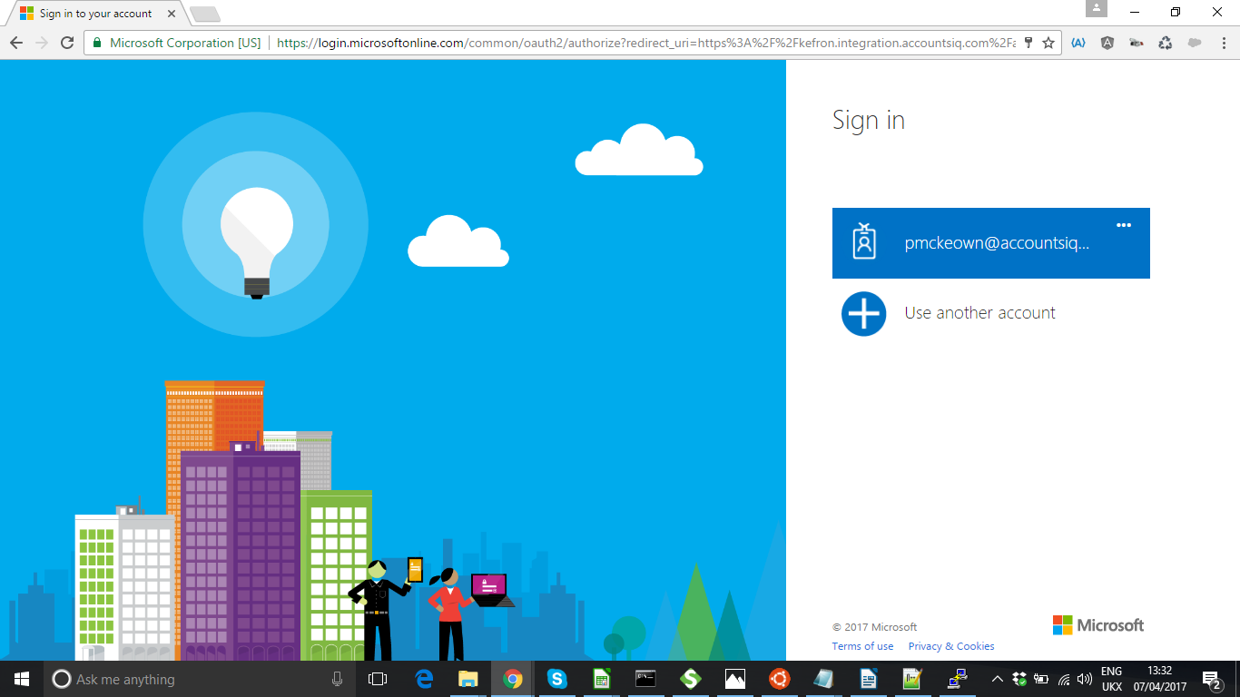

Step 1 – choose a connection:
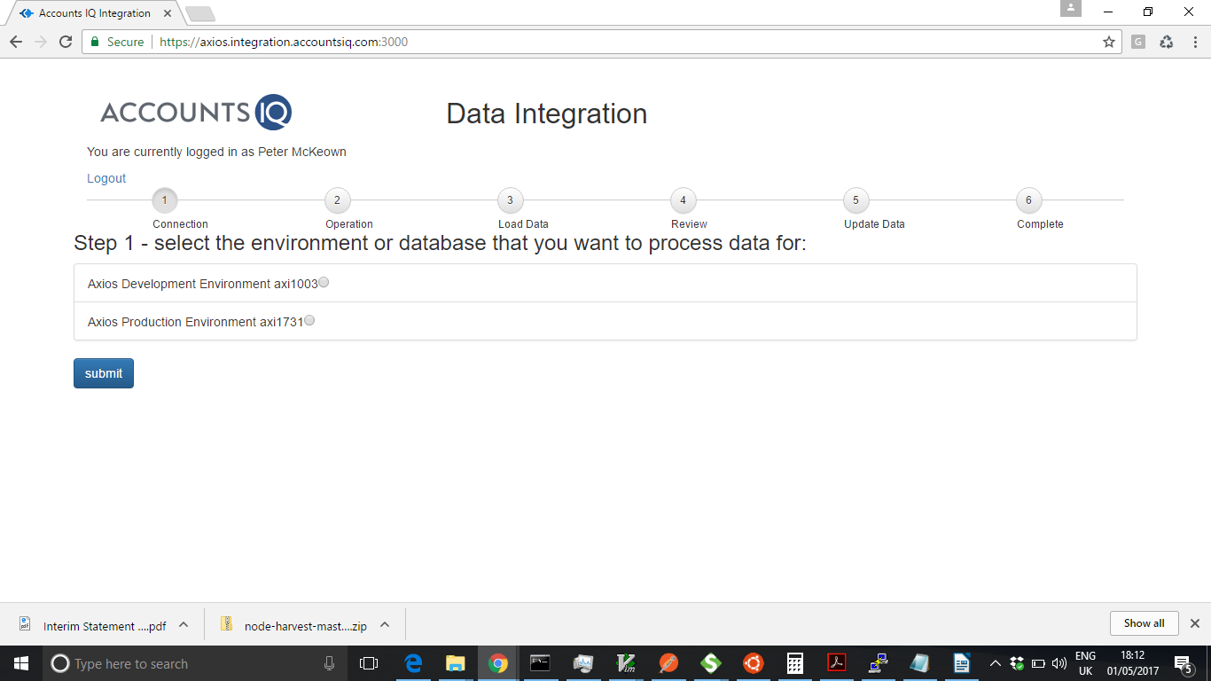

Pick an environment and click “Submit”
The Axios production environment uses AXI1731 but will also update AXI4318 and AXI1717.
The development environment loads data to AXI1003 (with transactions that would be loaded to AXI1731), AXI1004 (AXI4318) and AXI1002 (AXI1717)

Step 2 – choose an integration to run and click Submit

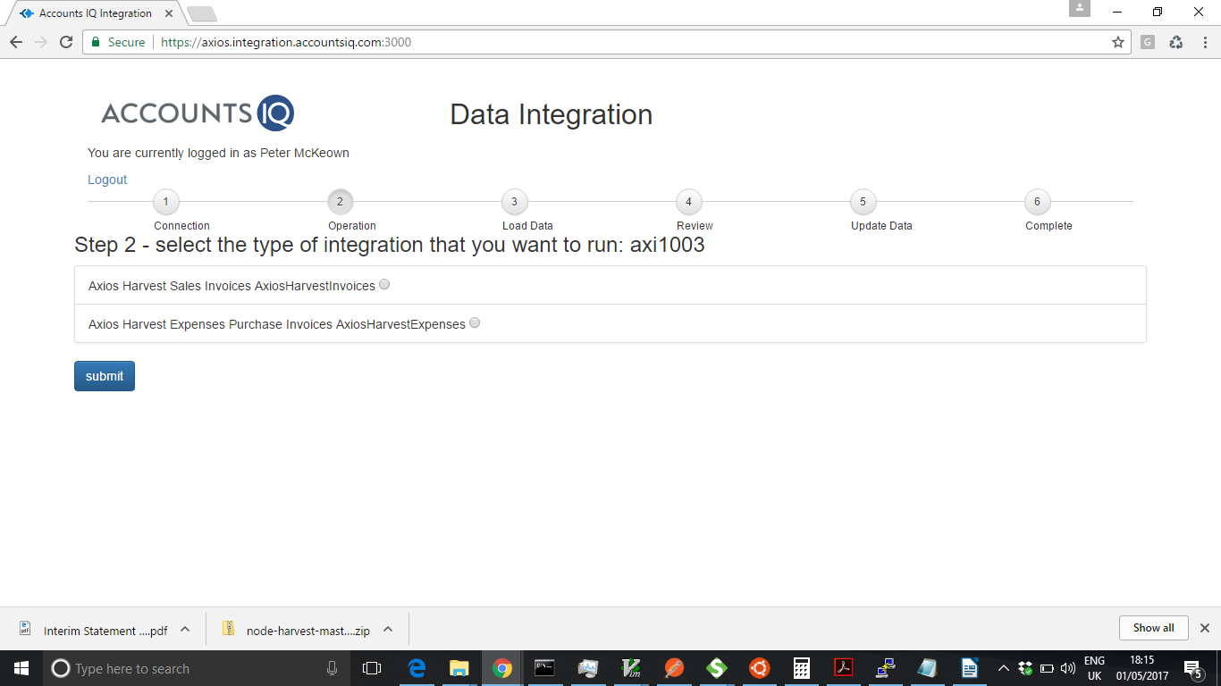
Step 3 – Select the date range to extract data from Harvest to Load the Data

The “Refreshing data” table shows the objects (such as Supplier or Customer Code) that need to be validated. The codes that you have currently set up need to be refreshed (so that we can check for any new codes). Whilst the extract is in progress a “refresh” icon will be shown. When the extraction is complete it will show a “tick”. Ideally you should wait until all show a “tick” (but you can proceed if you know that no new data has been set up).

Enter the date range that you want to extract data from Harvest. For invoices any invoice produced with a status of sent or paid in the timeframe will be extracted. For expenses any the process gets a list of all people in the organisation and extracts any expenses for them in the time frame that have not already been marked as “UPDATED_AIQ:” at the beginning of the notes field in harvest.

Click “Next – load the data” to proceed.
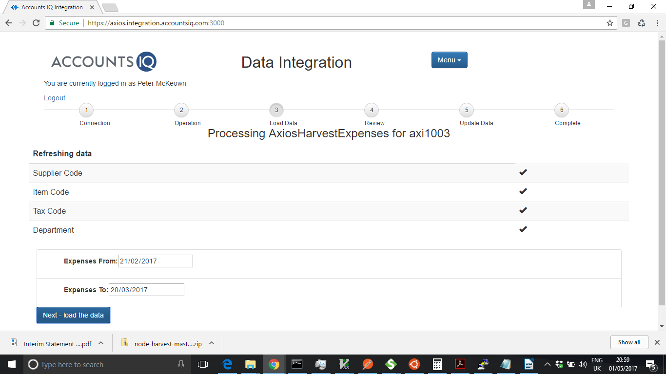

A window will pop up showing the progress of loading the data.
The first step is to extract the data from the Harvest and format it to be into the format required for the document(s) to be loaded to accountsIQ. Due to limits on the number of API calls to the Harvest system this may take a minute or two to complete.
When complete a message will be displayed along with an “OK” button. The number of documents formatted for accountsIQ will also be displayed.

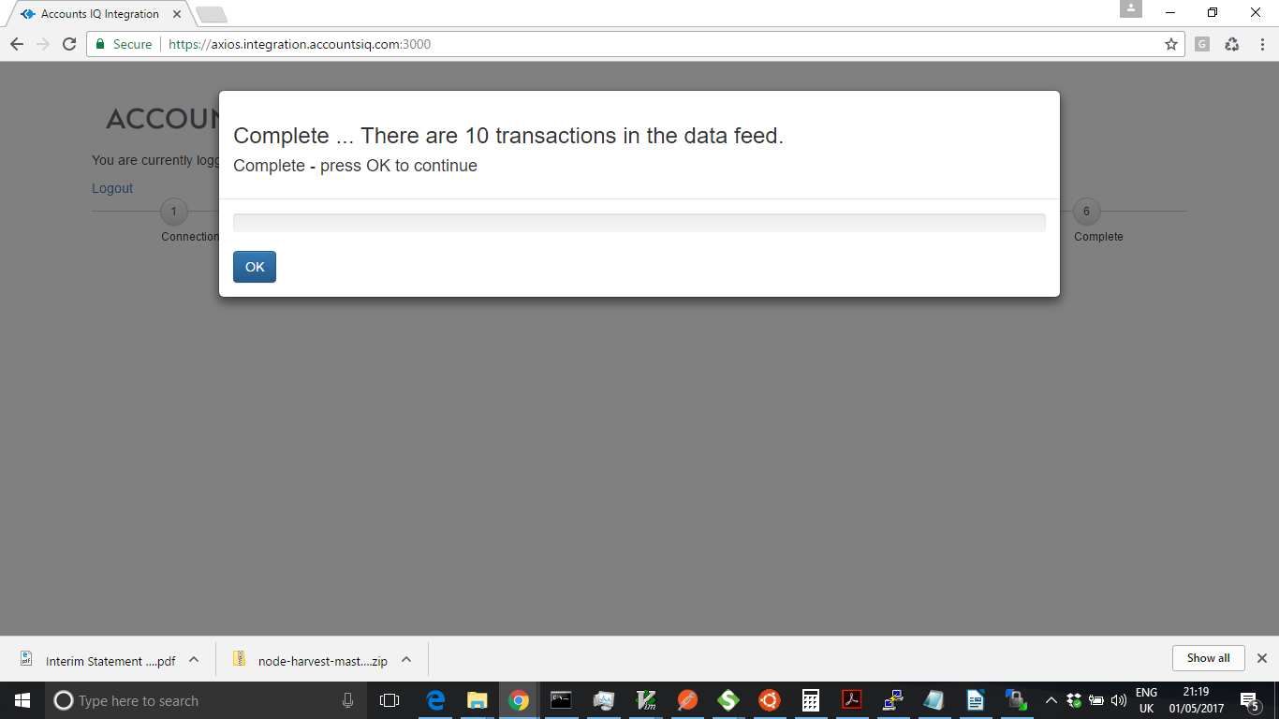
Press OK to return to the main screen. A summary table will show the number of transactions found in the source data (Feed Record Count) – which will equate to the number of documents to be loaded into accountsIQ.

It will display the number of transactions (documents to be loaded to accountsIQ), and the number of lines across all of the documents. The number of errors (documents and lines) that failed validation will also be displayed.

If there are any errors they will be displayed in a table. A document will be in error if any of the lines are in error. Errors are usually where the data validation has failed (so a Customer Code supplied in the data feed was not found in the extract taken from accountsIQ). The error below is a “designed in” error as one user in the Harvest system (accounts.payable@axiosint.com) is not to have the expenses loaded into an accountsIQ database (hence the supplier code is matched as “NONE”). The second error is related, in that the tax codes are set from the supplier code.
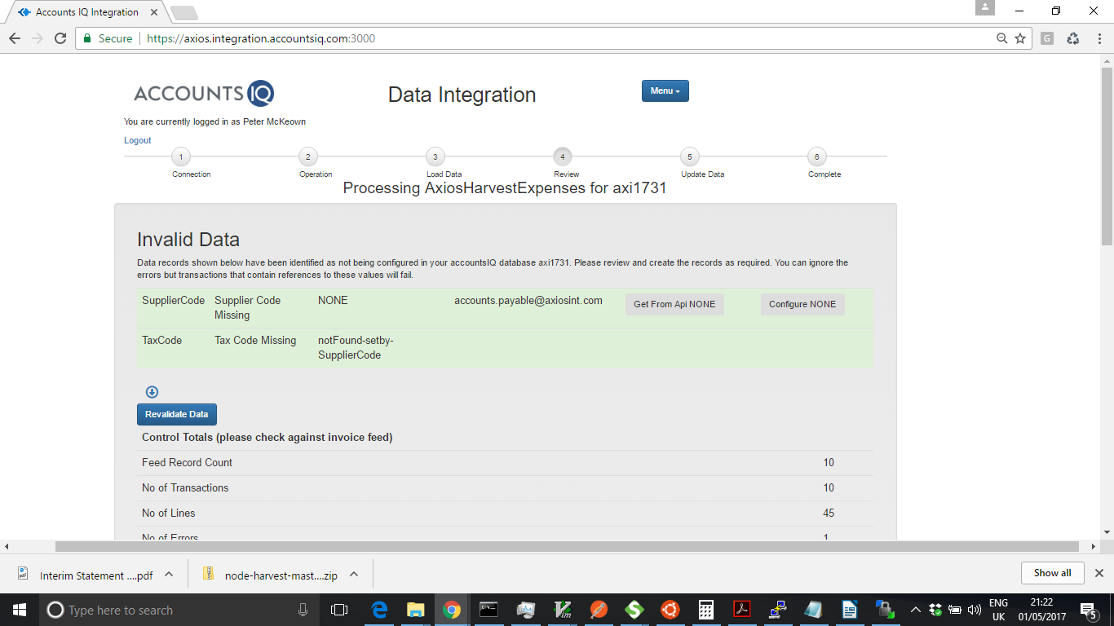

In some instances you will want to create accounts (supplier or customer) or departments or stock items in accountsIQ before proceeding. You can use the “Get From API” button for suppliers (people) or customers to load the data that is held in Harvest to allow you to create a customer or supplier in accountsIQ. You will after then need to “Configure” the account before you will get a “Create” button that will allow you to load the account data into accountsIQ.

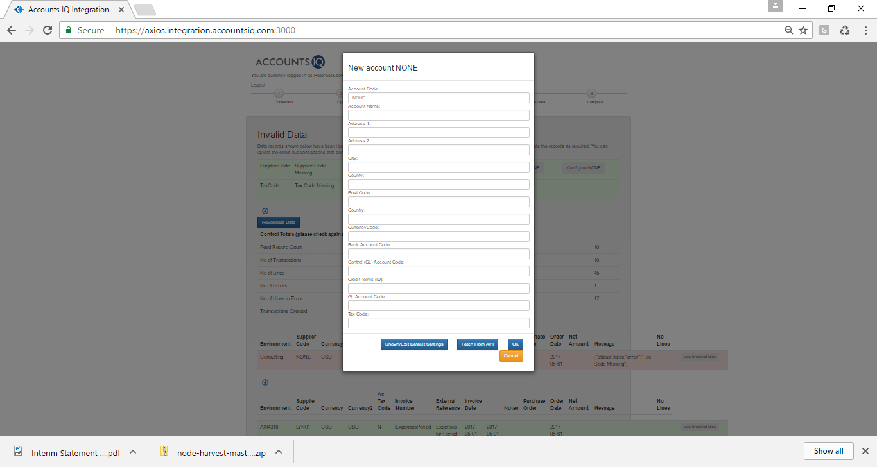

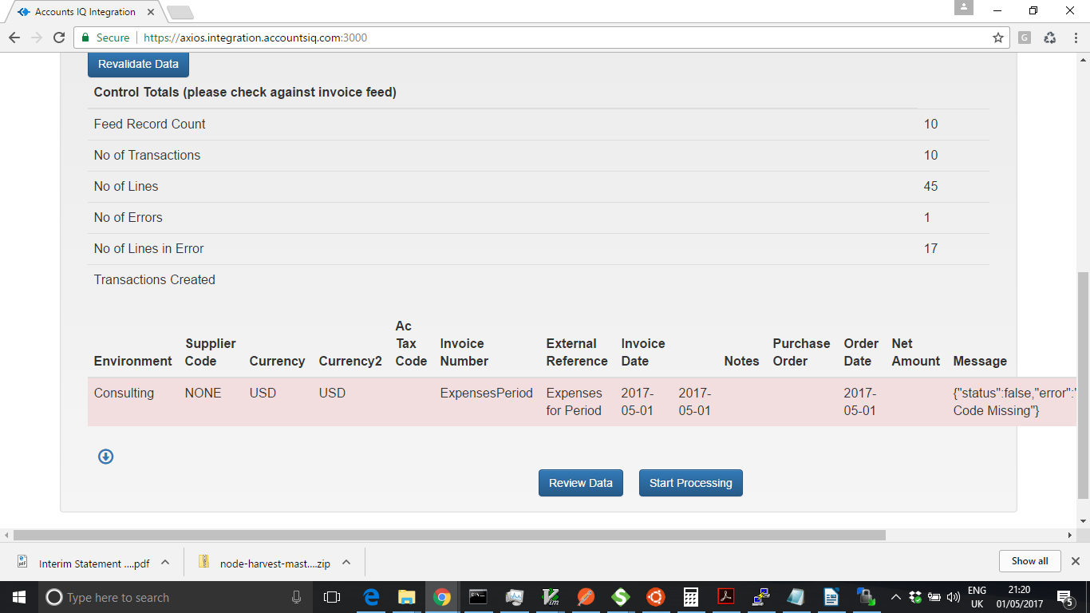
You can review all the transactions by clicking on the “Review Data” button.

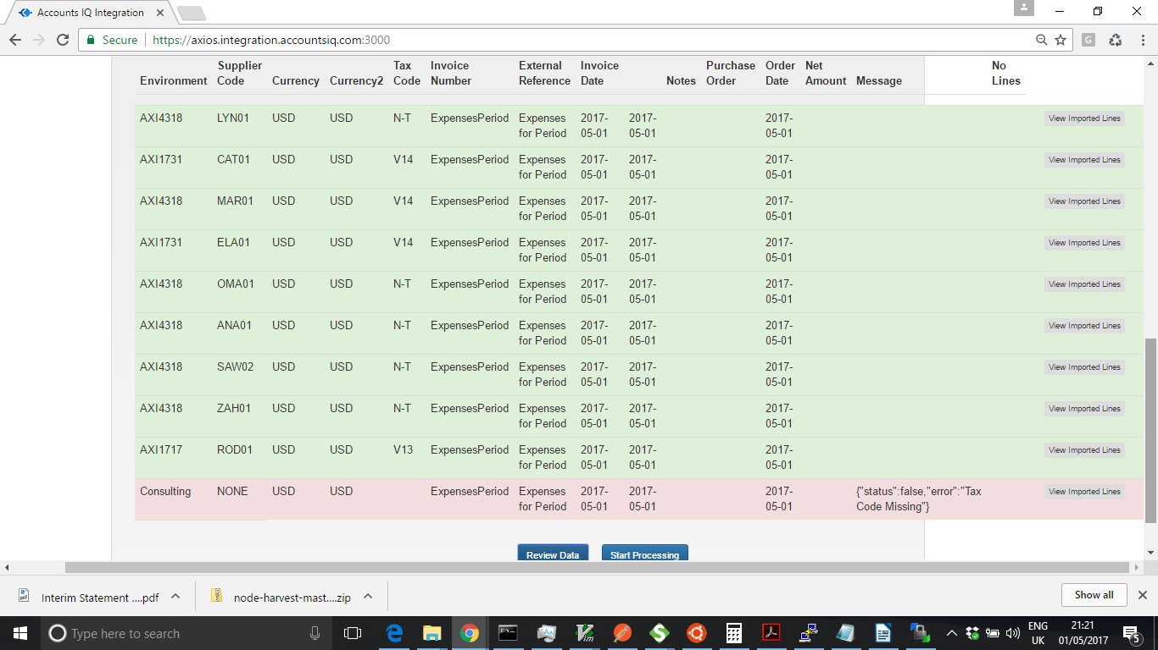
You can use the “View Imported Lines” to see the documents detail as shown below.
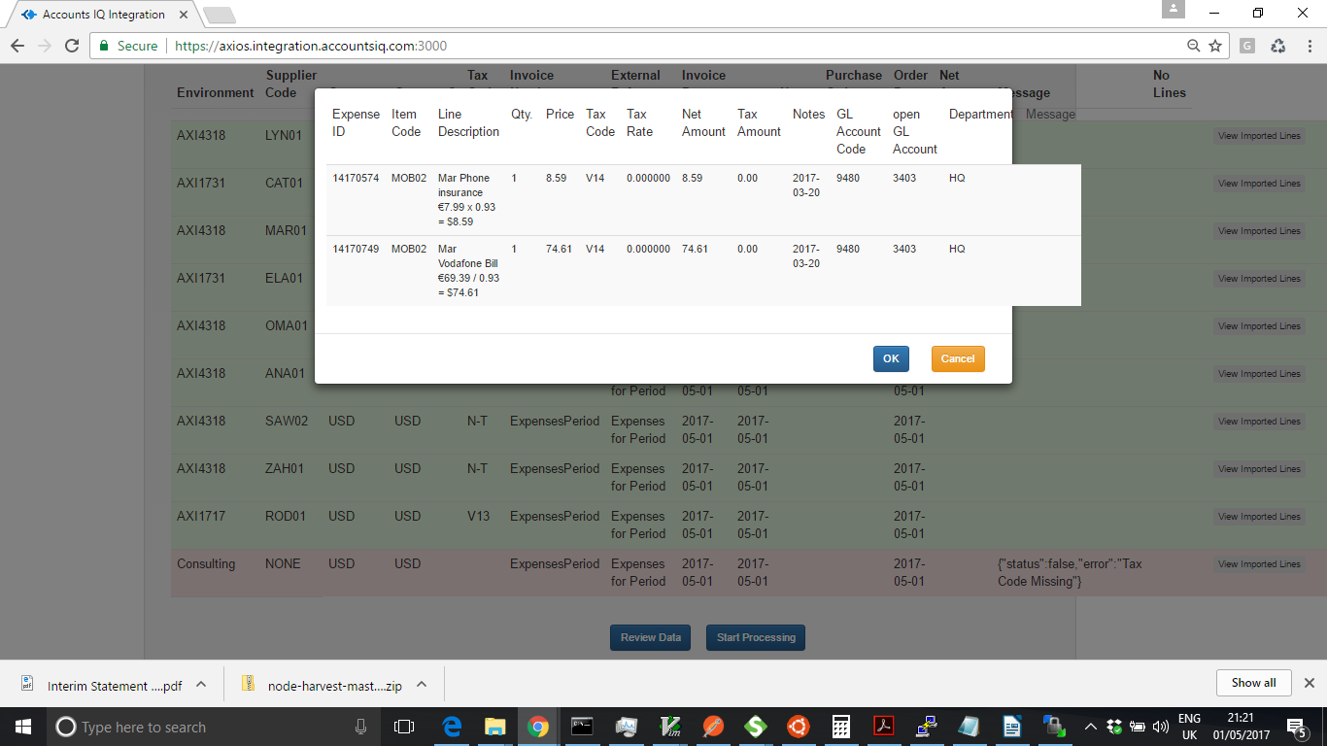
When you have reviewed the data press “Start Processing” to load the data into accountsIQ. Any documents that are in error will NOT be loaded. A pop up window will show the progress.

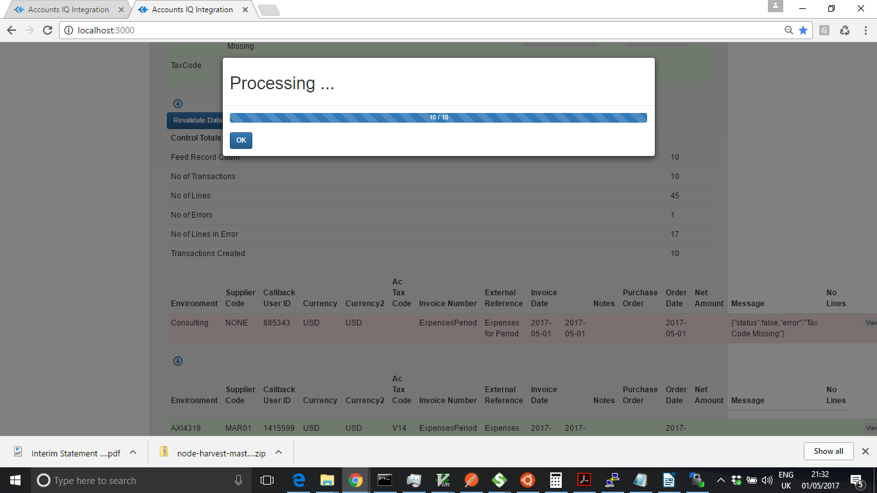
A summary of the data update status will be shown when you press OK. You must review this to ensure that the data has all uploaded

